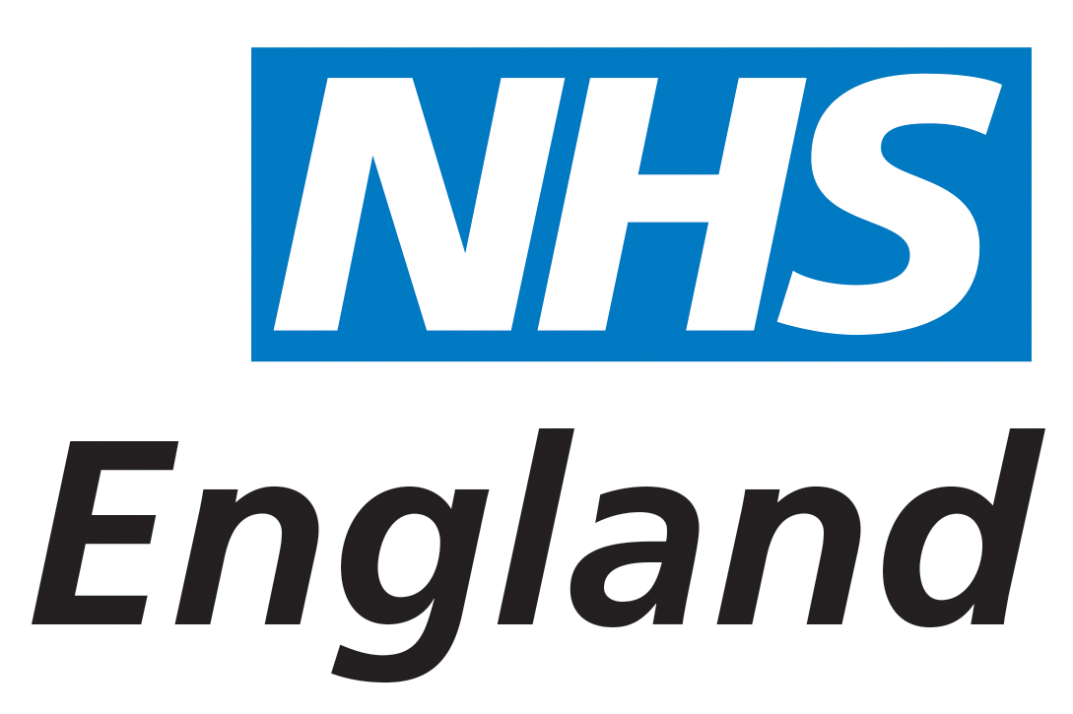
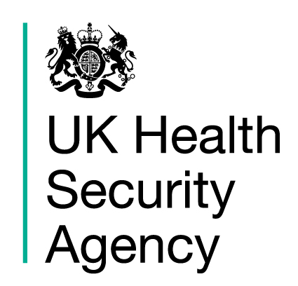
Restricted: Personal
20 September 2021
Invitation letter for parents of children aged 12 to 15 years of age
Dear Parent or Guardian,
COVID-19 vaccination for children aged 12 to 15 years of age

I am writing to inform you that we will soon be offering COVID-19 vaccinations in school. I would like to ask if you wish to give your consent for your child to receive a first dose of the vaccine.

This vaccination will be free of charge and our highest priority is making it easy for children to access one dose of the vaccine before the winter.

The main purpose of the COVID-19 school age vaccination programme is to provide protection to the children who receive the vaccine and may help to reduce transmission of COVID-19 in the wider population. We have included some information leaflets for you and your child to read.

During the vaccination delivery the vaccination team will maintain a range of measures to keep your children safe from COVID-19.

Once we have your consent, we will schedule the vaccination appointment, working closely with your child’s school.

Please indicate your consent by returning the attached form to a member of school staff.
By consenting you will be helping to play your part in reducing the risk of COVID-19 spreading.
Best wishes,
NHS Fylde Coast Clinical Commissioning Group
Telephone Number 0300 790 6856
Information about COVID-19 vaccines is available at: www.nhs.uk/conditions/coronavirus-covid-19/coronavirus-vaccination/coronavirus-vaccine.

