How are mental health and attendance linked?
When a young person is struggling with their mental health school attendance can be affected.
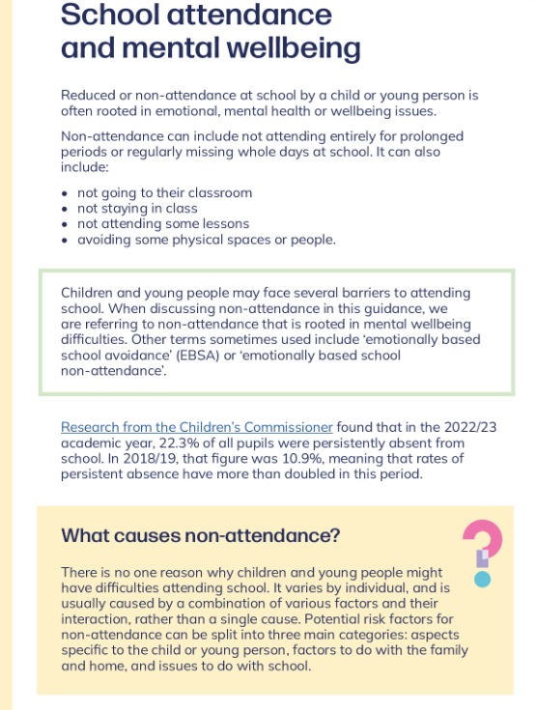

A great website for resources, guidance and support around supporting a young person’s mental health can be found below - Children's mental health - Every Mind Matters - NHS

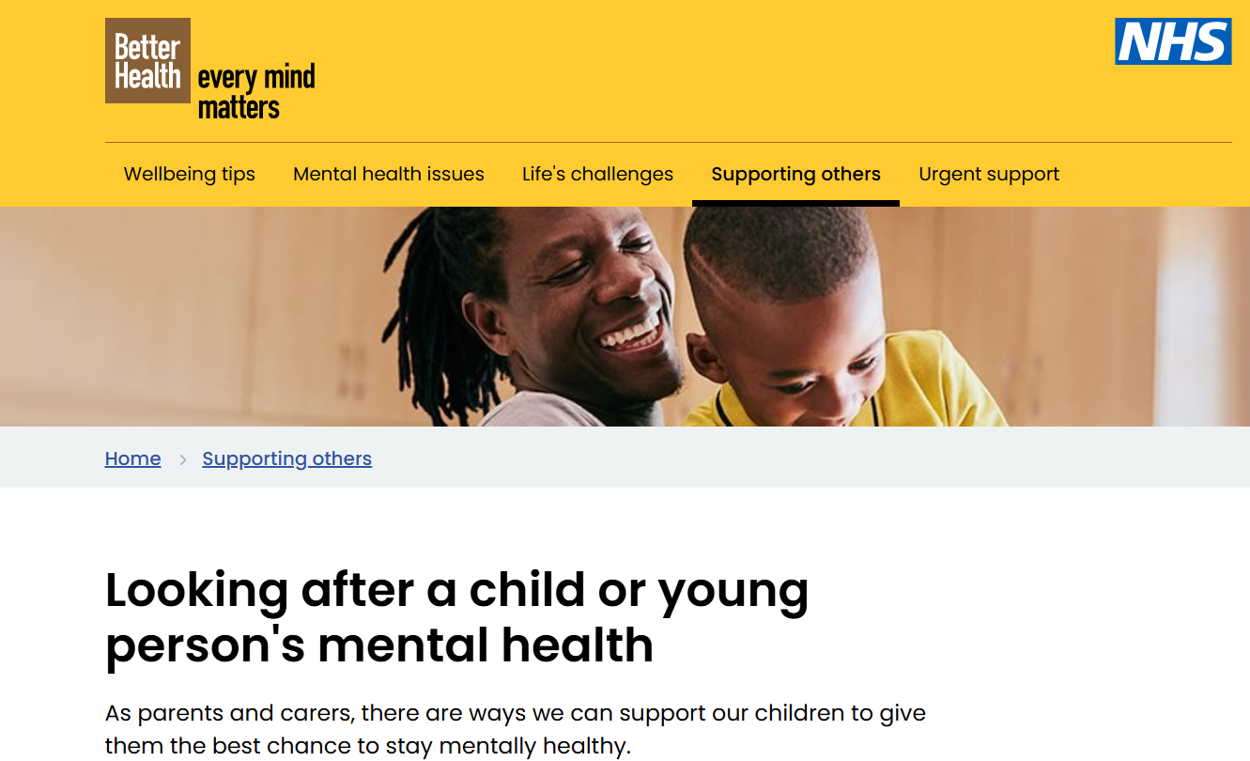

Email contact in school – sharpr@brookfield56.lancs.sch.uk Please feel free to email for advice on where to find more resources to support your child’s wellbeing or with any concerns you have.

